Wise Words - Man and Wife
Gary Wise
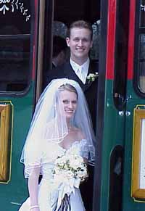
With all the positive response I've been getting in the last couple of weeks concerning Wise Words, I hate to make a departure from what seems to be working, but the biggest uncovered event of the Magic year happened in Madison, Wisconsin last weekend and now, as I sit in Madison's Dane County Regional Airport waiting for the plane back to Toronto, it occurs to me that a recapping of the weekend's events might prove to be a good way to give insight to not only that event, but to the interactions of some of the Pro Tour's finest.
The event in question, also being called PT Wisconsin or PT Madison, was Bob Maher's wedding. Time and again, I've gone through the process of doing the needed laundry, banking, packing and planning to prepare myself for a trip ahead, but I've always done so with the understanding that a strong performance play-wise could cancel out the financial concerns of that given trip, so this one was a new experience for me. In hindsight, I definitely made the right decision in making the journey.
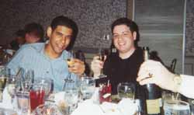
I don't know how many Magic players there are out there for who I'd throw down a few hundred bucks for airfare, get my one good pair of pants tailored, buy a new dress shirt and do all the little things one needs to do in preparing for this kind of trip, but Bob Maher is a special case. Bob and I go back around six years to a time when he was a junior and I was more of a scrub than now and both of us were trying to qualify for the Pro Tour. Bob and I played Type I for ante at Origins while most of our eventual colleagues were playing at PT Columbus (all those years ago) and despite my obvious bitterness in losing a Khabal Ghoul, we became fast friends.
Bob, known as The Great One, earned his nickname with his great capacity for top-decking against the likes of Nate Clark and Feming Chan, but the name is indicative of something greater. Like his father said at the wedding, Bob seems to live a charmed existence, with everything from his marrying his childhood sweetheart to being born into an high upper class family to his good looks and charismatic presence seemingly going his way.
With all that and, for those of us who care about such things, a Player of the Year title to his credit, what makes Bob special is his humility. One would expect that financial security, success in many an endeavor and all the rest might go to one's head, but the opposite is actually true. While Bob faces up to the responsibility his gifts provide constantly, he very effectively convinces all who meet him that he's the antithesis of all those rich kid movie characters we've come to expect to hate.
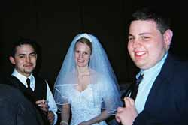
Bob's Magic career appeared to be over when the self described 'over the hill' Madison native won PT Chicago in 1999, but that victory along with his success at World Championships and other tourneys has lifted him to Magic's pinnacle. The 6'4 fresh-faced all-American is now succeeding in ways he'd only dreamed of years ago.
This brings us to today. With such a popular, well-rounded person will obviously come lasting relationships and impressions that prove useful from time to time. Bob has done business with Mike Long and Mark Justice, drafted with Jon Finkel and Steve O'Mahoney-Schwartz and traveled the world with Dave Williams. Many of these friends (all of those listed but Long) and others made their appearances this weekend, for a celebration few of them will soon forget.
When I received the invitation, my initial action was to secure lodgings. I got in touch with Mike Hron, who rooms with the now-infamous Dan Bock and got his go ahead on my plan to crash at his place. I arrived to a true gamer's den: Boxes and cards and sci-fi videos littered the apartment, with even the skylight being decorated by one lone Magic card (I never did find out what it was.). We awaited the arrival of Dustin Stern, Adrian Sullivan, 6-time pro Bob Allbright and Matt Severa, watching a little TV and playing some 5-Color and chess before we headed out to the local gaming store at 11:30 PM or so.
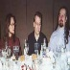
When we arrived, it was a veritable who's who of American Magic. With Jon Finkel, the OMS brothers, Ed Fear, Dave Williams, Kurtis Hahn (creator of the 5-Color format) and the collective Madison gaming community assembled, we discussed the rumor that US Nationals would include an Invasion-Planeshift-7th Edition booster draft (Editor - This is actually a false rumor, US Nationals is Invasion/Planeshift and Canadian Nationals is Invasion/Planeshift Apocalypse) and drafted that format as practice, with Williams, Fear and I taking on Severa, Allbright and Ben Kellerstrass, losing 5-4.
Now, also in attendance was the majority of the wedding party, including both Bob and his father, Bob senior. The elder Maher has played a little Magic but watches a lot of it, supporting his son's gaming endeavors with the watchful eye of a father and the enthusiasm of a spectator. That night, big Bob did his first draft, teaming with his son against Derek Rank and Jason Woodburn, both PT veterans for a 2-on-2. Mr. Maher is now 1-0 lifetime drafting.
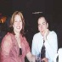
The next day started with a noon wakeup followed by a little adventure in trying to find some breakfast. A bunch of us including Bock and his girlfriend Julie headed out to this pancake house that we found was not only closed, but boarded up too. Amidst a few jokes of just how bad the flapjacks actually would have to be to necessitate this, we eventually grabbed a little something at TGI Fridays.
We gamed away the afternoon and we arrived at the chapel at 3:30. After hanging with the likes of Finkel, Williams and Dave Price for years, it was a little weird to see them all dressed up, especially Price, who admitted he'd purchased everything he was wearing in the last 48 hours. Dave was there with Lauren Passmore, and the presence of Donnie and Rose Gallitz and Mark Justice, presently living in Utah, made the group complete.
As the ceremony began, a remarkable thing happened: Bob started bawling. As Andy Nishioka, his best man would later recount during the dinner speeches, he'd brought emergency tissues for Courtney, Bob's wife by the end of the night, but hadn't taken into account the possibility that he might need enough for both of them. I was actually pretty happy to see Bob getting that emotional as it not only showed his human side but also meant he was really experiencing one of the moments of his life. The entire scene was remarkable.
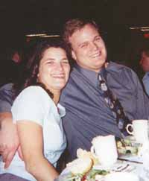
After the 'I do's were exchanged, there was a short reception in the chapel and we then made our way over to the hotel where the reception was being held. There were three Madison tables and a PT table, and when Finkel, the OMS brothers, Williams, Fear, Price, Passmore and I all sat down, the jokes inevitably started flying about doing 8-person drafts during the speeches.
While the booster packs were never broken out, Magic was obviously present. The game plays enough of a role in Bob's life that Courtney had made copies of a card called Oath of Love, depicting the newlyweds as a wedding souvenir for each guest. Speculation of the e-bay value of the things began immediately but everyone seemed to agree that the Oaths were keepers.
After Nishioka did his obligatory roasting of the groom and Courtney's father made his speech talking about 19 states being represented (no mention was made of the extra country - how insulting!), Bob's father led a toast that seemed remarkable in its simplicity. With the assembled crowd awash in Dom Perignon, Mr. Maher congratulated his son on the best top-deck of his life. While the non-gamers in the crowd wondered what that meant, our table was amazed at how blatantly Bob Sr. had stated that this was his son's day: It was everyone else's job to keep up if possible.
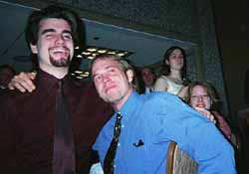
The rest of the night went off without a hitch. Our table drank around three bottles of Dom. There were no problems with seating arrangements, which could have gotten ugly with different personality clashes. Bob eventually thanked everyone for coming, pointing out how moved he was by each individual who made the trip. He even proved this (in my personalized view) in correcting his father in-law's earlier oversight, reminding the assembled that there are two countries represented here. I later found out I was the only Canadian in attendance.
Eventually, as assembled gamers are prone to do, a group of the Midwesterners made their way to Tim McKenna's room to draft after we met Bob's cousin JJ Dowling, a wide eyed kid meeting the best players in the country, who will be competing in the Junior Super Series. Cigars were smoked, drinks were drained and everyone was happy. The event went off without a hitch.
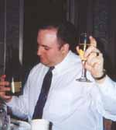
Today (Sunday), amidst feelings of burnout, a bunch of us got together to draft. It was a nice reminder of the greater force (Magic) that had brought us together here. Price, Passmore and I just barely caught their hotel shuttle. So far, the flight home has gone without a hitch.
So what's the point of all this? This is supposed to be a column about Magic, Magic players and Magic playing. This is not supposed to be Soap Opera Digest for the Pro Tour's stars. Simply, I think the example this weekend sets is a good one to remember in all endeavors in life: There's always something more important. It was more important for Bob to cry than to worry about what his assembled friends might think. It was more important for his dad to show his support by using a Magic phrase that the assembled family wouldn't fully comprehend. It was more important for Courtney to accept her new husband's lifestyle by creating Oath of Love, and it was more important for me to be here to celebrate a friend's life moment.
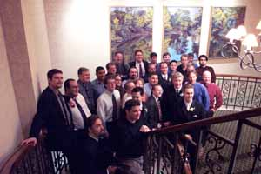
Magic is a good time for anyone who wants it. With its ever-changing nature, we can avoid boredom for much longer than any of us thought possible. In our desire to succeed, we alienate family, shorten our attention span for other things and spend a lot of money. In Bob, Courtney and their wedding, we can come to an understanding that in the end, it is just a game. Have fun with it, enjoy those you play with and never lose your enthusiasm, but remember that in the end, we have to prioritize. It's only when your life is in proper order that you truly appreciate what we have.
That's about it for this week, hope you got the message here and understand why I wrote it. Congratulations again to Bob and Courtney, thanks to Hron and Bock for the hospitality, and props to everyone who made the trip. This time I have no slops. Have a good week.

